Part A: Understanding Table Joins

There are 2 tables: Customer table and supplier table.

|  |  |  |  |  |
| --- | --- | --- | --- | --- |
| **Table 1** | |  | **Table 2** | |
| **Customer ID** | **Name** |  | **Supplier** | **Name** |
| 101 | Pirate |  | 101 | Frogs |
| 102 | Pokes |  | 102 | Texans |
| 103 | Cowboys |  | 103 | Jaquars |
| 104 | Frogs |  | 104 | Pokes |

**\*\*Inner join\*\*** produces only the set of records that match in both Table A and Table B.

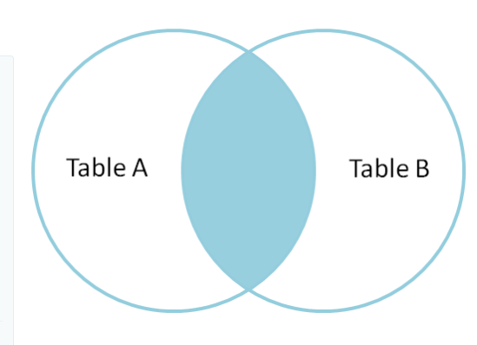

|  |  |  |  |
| --- | --- | --- | --- |
| **Inner Join on Name Results** | | |  |
|  |  |  |  |
| **Customer** | **Name** | **Supplier Name** | |
|  |  |  |  |
| 102 | Pokes | 104 | Pokes |
| 104 | Frogs | 101 | Frogs |
|  |  |  |  |

**Full outer join** produces the set of all records in Table A and Table B, with matching records from both sides where available. If there is no match, the missing side will contain null.

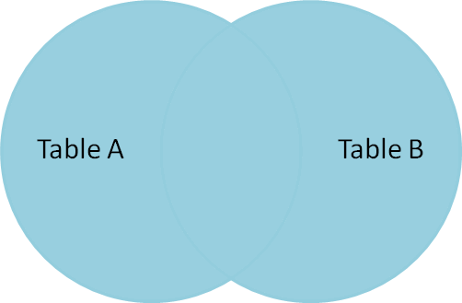

|  |  |  |  |
| --- | --- | --- | --- |
| **Full Outer join on Name Results** | | | |
|  |  |  |  |
| **Customer** | **Name** | **Supplier Name** | |
| 101 | Pirate | null | null |
| 102 | Pokes | 104 | Pokes |
| 103 | Cowboys | null | null |
| 104 | Frogs | 101 | Frogs |
| null | null | 102 | Texans |
| null | null | 103 | Jaquars |

**Left outer join** produces a complete set of records from Table A, with the matching records (where available) in Table B. If there is no match, the right side will contain null.

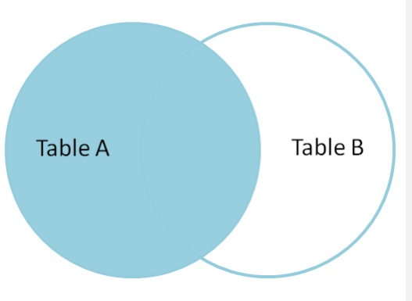

|  |  |  |  |
| --- | --- | --- | --- |
| **Left outer join on Name Results** | | |  |
|  |  |  |  |
| **Customer** | **Name** | **Supplier** | **Name** |
| 101 | Pirate | null | null |
| 102 | Pokes | 104 | Pokes |
| 103 | Cowboys | null | null |
| 104 | Frogs | 101 | Frogs |

**Left outer join** produces a complete set of records from Table A, with the matching records (where available) in Table B. If there is no match, the right side will contain null.

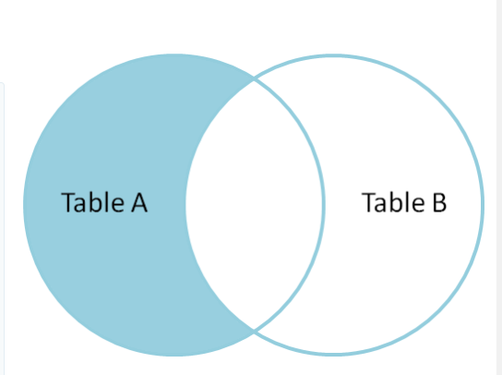

|  |  |  |  |  |
| --- | --- | --- | --- | --- |
| **Left outer join with only name in Table A Results** | | | | |
|  |  |  |  |  |
| **Customer** | **Name** | **Supplier** | **Name** |  |
| 101 | Pirate | null | null |  |
| 103 | Cowboys | null | null |  |

Part B: GBI – Connect tables in Tableau

### We will use Global Bike Data for this exercise. Download files in the folder named GBI Tableau data.

1. Open Tableau
2. Start by connecting to the GBI_Sales_Transactions Spreadsheet. Select Connect 🡪 Microsoft Excel.
3. Find the location where you stored the datafiles and select GBI_Sales_Transactions.

1. Then add the connection for the Customer Spreadsheet by clicking on **Add**

1. Create a join between the two tables.
   1. Drag and drop the GBI_Sales_Transactions spreadsheet (if it is not already there)
   2. Drag and drop the Customer spreadsheet (if not already there)

Drag and Drop Sheets

* 1. The connection will be red. To create the connection, find the Customer Field in the Customer table. Make sure the field is formatted as a String. If the connection is still red, find the Customer Field in the Sales Transaction table. Make sure the field is formatted as a String.

1. Add the Sales Org Spreadsheet and Connect the Sales Org spreadsheet by drag and dropping the SalesOrg Sheet

CHECK THE JOINS!!! IT IS NOT CORRECT.

* 1. Join the Sales Org table to the Customer Table with the correct fields. (Sales Org to Sales Org)

1. Add and Connect the Material spreadsheet
   1. Fix the join by joining **Product** field in the Sales transaction table to **Material** field in the Material table.

1. Add and Connect the Product Category and build the proper join. (Product Category)
2. Check each field in the joined table and make sure all the fields have the proper format.
   1. Hint: Sales Order number, Order Line number, Quote Number and Quote Line Item should be strings.
3. Change the data from Live to Extract. Then change it back to live.
   1. Note: If you move your excel spreadsheets to another location, you will have to reestablish connections.
4. Your connection should look like the one below.

Part C: GBI – Data Preparation

Before making visuals, preparations may be needed to ensure effective visualization. The following steps will prepare our GBI data for use.

**Hiding Fields**

Hiding fields will make the list shorter and get rid of redundant data in our data set.

To hide a field, find the field you want to hide and select the down arrow in the upper right hand corner.

Then select the word Hide. The Field will no longer be viewed.

For this exercise hide the following fields:

1. All Language Keys

2. Product Category Code (just 1)

**Adding Calculated Fields**

The original dataset included currency in both EUR and USD. To ensure we are calculating values correctly, we will convert all dollar values into USD. Let’s start with revenue. To Create a Field named Revenue USD find the revenue field in the dataset and select the down arrow. A pop up box will appear for you to enter your formula.

NOTE: Another alternative to create a calculated field is from the Menu Bar on a Sheet. C

Select Analysis 🡪 Create Calculated Field. A pop up box will appear.

Change the formula name to RevUSD and enter the following formula: (YOU CAN COPY AND PASTE)

IF [Currency] = "USD"

then [Unit Price] * [Quantity]

ELSE

[Unit Price] * Quantity * [Exchange Rate (USD/Euro)]

END

Field Name

Formula

Message Area

Apply to apply formula

OK to exist

Select Apply then OK.

We will repeat this process to create the following fields

|  |  |
| --- | --- |
| **Field Name** | **Formula** |
| DiscountUSD | if [Currency]= "USD"  then [Discount]  ELSE  [Discount]* [Exchange Rate (USD/Euro)]  end |
| COGSUSD | [Unit Cost at Goods Issue USD] * [Quantity] |
| GrossProfitUSD | RevUSD – COSGUSD - DiscountUSD |
| GrossProfitMargin% | [GrossProfitUSD] / [RevUSD] * 100 |
| Discount % | [DiscountUSD] /[RevUSD] |
| StdCostVariance | ([Unit Cost at Goods Issue USD] - [Product Cost USD])* [Quantity] |
| SalesPriceVariance | if [Currency] = "USD"  then ([Unit Price] - [Sales Price USD]) * [Quantity]  ELSE  (([Unit Price] * [Exchange Rate (USD/Euro)]) - [Sales Price USD]) * [Quantity]  end |

**Creating Geography Roles**

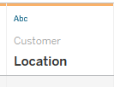

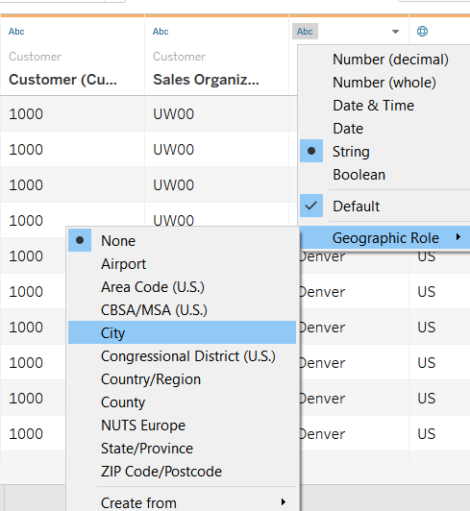

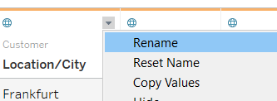

In order to use a field on a map, it must be assigned a Geography Role.

Find the **Location** field in the dataset. Notice it has a character as Abc (string), however, the location is actually the city.

We will modify it so it become a geography role, by clicking on the field type in the upper left hand corner and then selecting Geographic Role. Select City.

Notice the field sign now showing a globe.

Find the country field. It should already be specified with a Geographic role or country/region.

Let’s also rename the field Location/City by clicking the down arrow in the upper right hand corner of the Location Field and selecting Rename.

**Creating Hierarchy**

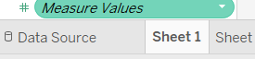

Hierarchy allow you to drill down within your data. We want to create several hierarchy in our data set. To create a hierarchy, we must first go to a sheet. Click on sheet 1 at the bottom of Tableau. This will bring up a blank sheet.

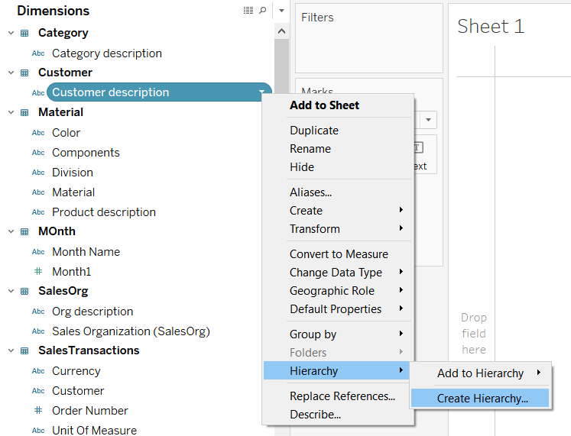

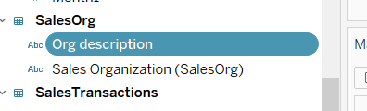

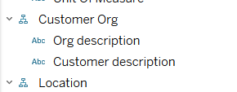

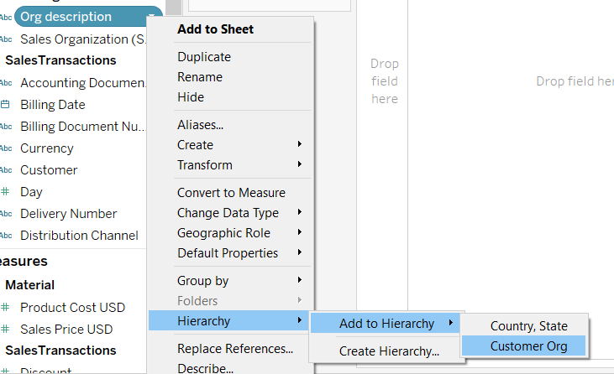

Let Start by creating a hierarchy for customer organization. This will include sales organization description (ORG Description) and Customer Name We have 2 option for setting up this hierarchy : 1) by number or 2) my name/description. We will choose to use names and descriptions.

**Steps:**

1. In the Data Pane, find the dimension Customer Description. Select the down arrow on the right side then Hierarchy 🡪 Create Hierarchy.
2. In the pop-up box name the hierarchy “Customer Org”.
3. Select OK
4. Find the Field Org Description select the down arrow on the right then Hierarchy 🡪 Add to Hierarchy 🡪 Org Description
5. Make sure the Org Description appear before the customer description.
6. Since GeoCodes existed for Country and State a hierarchy has already been started. You will just need to rename and add City.

Repeat the creation of hierarchy for the following. Remember to consider whether you would like a build hierarchy using the field or its description.

Since Sales Organization is found in two hierarchy you will need to put the Sales Organization in one and the description in the other.

We are done prepping the data. Save Workbook as GlobalBike.

Part D: GBI – Tableau Basic Navigation

### We will continue to use our Global Bike Data to perform some basic navigation. It is just a quick orientation so you will know the basics and can start exploring for yourself.

Open the Global Bike Workbook. **New sheet** tabs are found at the bottom. We can create sheets, dashboards, and stories with these tabs. We can also do things like rename the sheets, drag to rearrange them, duplicate sheets, copy formatting, and many other things.

**A sheet**: A sheet is a single data visualization (such as a bar chart or line graph). Since sheet is also a generic term for any tab, we'll often refer to a sheet as a view because it is a single view of the data.

**A dashboard**: A dashboard is a presentation of any number of related views and other elements (such as text or images) arranged together as a cohesive whole to communicate a message to an audience. Dashboards are often interactive.

**A story:** A story is a collection of dashboards or single views arranged to communicate a narrative from the data. Stories can also be interactive.

**Create a new sheet** – this is a blank sheet. Sheets are where we build visualizations. Take a look at the workspace.

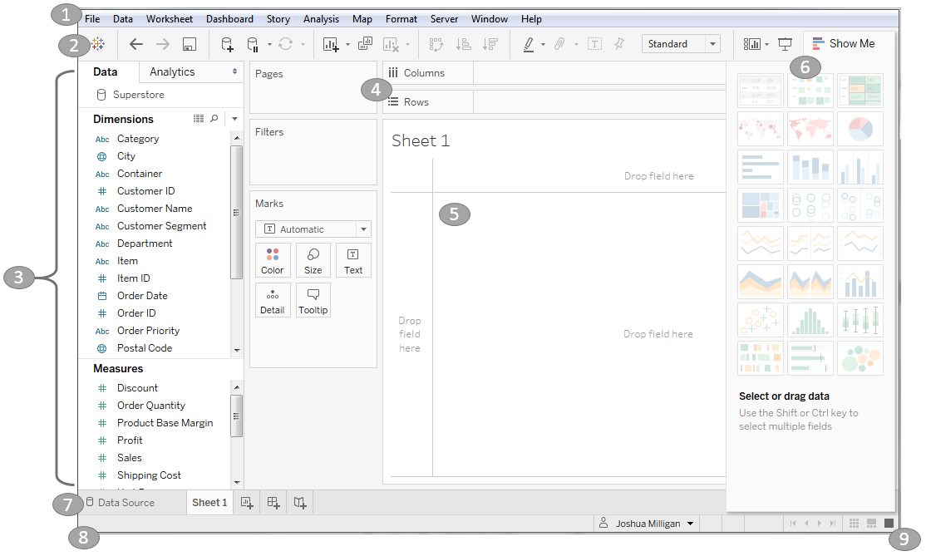

1. **Menus**. (The layout may look slightly different on a Mac.) The menus contain a lot of powerful controls – spend some time clicking through to see what options they contain.
   1. How do I add a row total?
   2. How do I show a caption on a worksheet?
   3. How do I format Legends?
   4. How do I connect a new data source using the menu?
2. Below is the **toolbar**, with common functions, such as undo, redo, save and add data source – there is no limit to how much you can undo, and this is a very important button that allows you to explore! (will be grayed out since we have not yet done anything)

Here we also have **save** – there’s no automatic save in Tableau, so make sure to save your work periodically.



NOTE: the **logo** button (or Home button)  which takes us back to the start screen where we can access saved data sources, recently opened or pinned workbooks, etc.

1. From the menu let’s connect the new data source by selecting Data 🡪 New Data Source. Add in the Currency file.
2. Go back to the sheet by clicking on sheet 1 at the bottom

1. Switch back to your original data source by clicking on the SalesTransaction under Data.

1. **Rename the SalesTransctions data source to “Sales Data” by right clicking on the data source and selecting rename.**

1. Rename the Currency table to “Currency Conversion”.

* 1. Are these two tables Joined?

1. On the left side of the screen is the data panes. window. If we’re on the **data pane**, the top lists all open data connections, and depending on which one is selected, the fields from that data source are listed below, broken out into dimensions and measures.

Dimension – Discrete fields used for slicing and Dicing

Measures - numerical fields used for metrics and numbers to analyze.

Remember: Dimensions come out onto the page as themselves while Measures come out onto the page as aggregates (default is SUM)

If we click to the **Analytics tab** we’re brought to an entirely new pane. Here we can bring out pieces of our analysis directly as drag and drop elements. More on this later. **Go back to Data tab.**

1. To the right of the data pane is what is referred to as the shelves (or cards). A view can be built by dragging and dropping fields from the data window into the canvas directly, or onto the shelves.

Various shelves, such as Columns, Rows, Pages, and Filters, serve as areas to drag and drop fields from the data pane. The Marks card contains additional shelves, such as Color, Size, Text, Detail, and Tooltip. Tableau will visualize data based on the fields you drop on the shelves. *Data fields in the data pane are available to be added to the view. Fields that have been dropped on a shelf are called in the viewer active fields because they play an active role in the way Tableau draws the visualization*.

1. The canvas or view is where Tableau draws data visualization. You may also drop fields directly onto the view.
2. SHOW ME: Show Me is a feature that allows you to quickly iterate through various types of visualizations based on data fields of interest.
3. The tabs at the bottom of the window give you the option for editing the data source as well as navigating between and added any number of sheets, dashboards and stories.

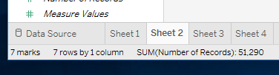

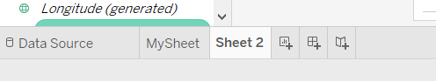

**Rename the Sheet**.

**Rename the first sheet “My Sheet” by right clicking on the Sheet 1 tab and selecting rename.**

1. As you work, the status bar will display important information and details about the view and selections. This shows the number of marks in the view as well as other summary information.

Make sure you select SalesData as your data source.

Go back to the **Data Tab** To**.** the right of each data field is a small down arrow. If you select the down arrow next to the field, You will notice there are many things you can do here for each field

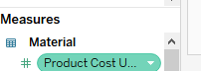

Let’s convert the Sales Order Number from a Dimension to a Measure by selecting the pull down menu.

D

Before you continue, familiarize yourself with the screen layouts shown in Figures 1 thru 5.

Figure 1: Worksheet Explained

Figure 2: Toolbar Button Explained

Figure 3: Showing tab, filmstrips or slide sorter

Figure 4 : Data Panel explained Figure 5: How to show Worksheet Description

# Let’s make a few charts:

1. Create a bar chart showing the number of orders placed by Customer Description. Drag and drop Customer description to the row and Drag and drop Sales Order Number count should be the column. It should similar to like this:

1. Open the Show Me pane. This will show you all the charts you can make based on the data selected. Change it to a tree map. The chart looks like the one below:

1. Now change the Chart back to a Horizontal Bar Chart. Switch the axis by selecting the  button.

1. Change the chart back to a Vertical Bar Chart and sort the data from the most orders to the least orders by using the sort button. .
2. Add Year as a column and change it to a line chart if needed. Drag Customer Description to Row.

Your chart should look something like this:

1. Create a new Sheet and call it Bicycle Sales Volume.
   1. Create a chart showing Category Description and Product as Rows and Sales Organization and the Sum of Quantity as Columns. (JUST Drag and Drop)

* 1. However, we only want to see Bike Sales. Therefore, we must filter the data. **Filter shelf** – this is an important feature that you are likely to use a lot.

Drag Division to Filters and select BI and then **Show Filter** by right clicking on filter pill and select show Filter. (formerly Show Quick Filter)

* 1. Select (ALL)
  2. Create a filter for Category description, by dragging and dropping the Category description into the filter shelf. Show filter on left.
     1. Why did we use category description instead of product category?
  3. Select only the descriptions with the word “Bike in it”. I could also select the ones without the word “Bike” and tell it to exclude.

1. Create a filter by year. Drag and drop the Year field into the filter box. We want to do a range of values from 2010 to 2012. Once complete select Apply. Then OK

1. We are now able to filter our chart by Product Category and Year. We can add as many filters as we need to our worksheet. To display the filters on my worksheet, Select the down arrow on the right side of the Filter Icon and select Show Filter. You now can see a filter on the right.

1. Year is showing as a continuous variable, but it really is a discrete variable and a string?
2. Change the Year to a discrete variable and data type of string. Instead of Continuous.
   1. What happened the filter on the right side?

* 1. IF the filter still exist, make sure it is also changed to Discrete. Select Show Filter again. Now what does the filter box look like on the right hand side.
  2. Select All to remove all check boxes then select only 2009 data.

1. We have numerous ways we can display a filter.
   1. Change the Year filter to a drop down in which you can only select a single value. Select the small down arrow next the Filter header and select Single Value List.

* 1. Change the Category Description Filter to a Wildcard Match. Select the small down arrow next the Filter header and select Wildcard Match.

* 1. What word do I need to put in the filter to only see Bikes? Display only Bikes
  2. Enter the word ‘Bike’ in the box below Category Description. Press enter.

1. You can hover over a bar on the charts to obtain additional information. This is known as a tooltip.
   1. What Information can you obtain from hovering over a bar?

* 1. What is the total sale quantity for RAAL1110 for each Sales Organization?

1. The Marks Card is made up of several other shelves, each of which can have fields placed on them and can be clicked to edit their properties such as type, color, size, shape, and so on. The fields on the Marks card are listed at the bottom of the card. Each field has an icon next to it to identify the mark property it is setting.
   1. Drag and Drop Sales Organization to Color from the Data Pane in the Marks area Color. Notice the bar colors changed.

Notice that the bars change colors and an legend was added to the right.

* 1. Drag and drop Quantity as a Label.
  2. We can also change the Mark from a Bar to other options. Right Click on the Mark options. Change to a Circle.

1. **Save your workbook.**